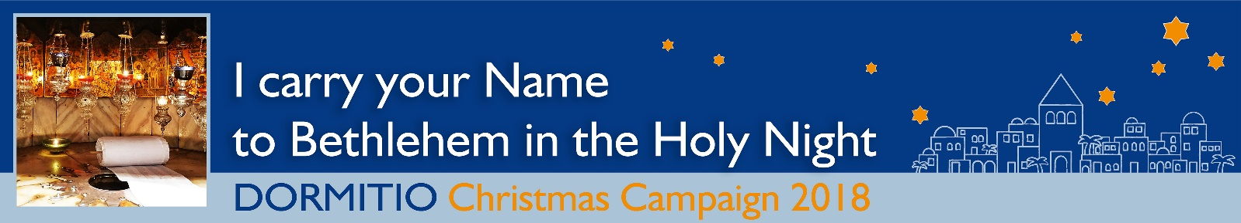

Send the names you would like to place on our scroll before Wednesday, 19th December 2018!
With a letter to: Weihnachtsaktion - Dormition Abbey - P.O.B. 22 – 9100001 Jerusalem/Israel
Please, consider that sending mail to Israel may take some days!
or as fax to: +972 2 5655 369
or with E-mail to: Weihnachtsaktion@Dormitio.net

Nr. | Name | Email-Adresse

